Import Data using Transform Maps (Spreadsheet)
Project Documentation
1. Introduction
• Project Title: Import Data using Transform Maps (Spreadsheet) – Team Project 10
• Team Members:
o Kaviya S – Team Member
o Kishore R – Team Leader (TL)
o Kousalya R – Team Member
o Lakshaya Harini RU – Team Member
2. Project Overview
• Purpose: To import bulk employee data received as an Excel spreadsheet into the ServiceNow platform accurately and efficiently using Import Sets and Transform Maps. The spreadsheet is first loaded into an Import Set table (a staging area); a Transform Map then maps the source fields to the target table, records are created or updated, and the result is validated. The project helps beginners understand the end-to-end data import process: data loading, field mapping, transformation execution and result verification.
• Features:
o Custom target table (Employee Test – u_employee_test) with the fields Employee ID, Employee Name, Email, Department and Location.
o Spreadsheet (.xlsx) upload through Load Data into the staging table Employee Import (u_employee_import).
o Transform Map “Sample Spreadsheet Import” with Auto Map Matching Fields and Mapping Assist for field mapping.
o Coalesce on Employee ID, so repeated imports update existing records and do not create duplicates.
o Transform History for verifying inserted, updated and ignored rows.
o Three reports on the Employee Test table: Employees by Department (Pie chart), Employees by Location (Bar chart) and Employee List Report (List).
o Employee Analytics Dashboards, a single dashboard that consolidates all three reports and can be shared with selected users, groups and roles.
3. Architecture
• Frontend: The project runs on the ServiceNow platform, so the user interface is the ServiceNow Next Experience UI rather than React. It consists of the Application Navigator, the Employee Test form and list views, Load Data and Transform Map forms, the Reports builder and the Dashboards workspace.
• Backend: Server-side processing is handled by ServiceNow Import Set and Transform Map functionality instead of Node.js and Express.js. The data flows as follows: Excel file (.xlsx) → Import Set table (u_employee_import) → Transform Map (Sample Spreadsheet Import) → Target table (u_employee_test). Coalesce on Employee ID decides whether a row is inserted, updated or ignored.
• Database: Data is stored in ServiceNow platform tables (not MongoDB):
o Staging table: Employee Import – u_employee_import (created by Load Data; columns come from the spreadsheet header row).
o Target table: Employee Test – u_employee_test, with the fields below.
Field mapping (Source → Target):
Column Label | Source Field (u_employee_import) | Target Field (u_employee_test) | Type
Employee ID | u_employee_id | u_employee_id (Coalesce) | String
Employee Name | u_name | u_employee_name | String
Email | u_email | u_email | String
Department | u_department | u_department | String
Location | u_location | u_location | String

4. Setup Instructions
• Prerequisites:
o A ServiceNow instance (for example a Personal Developer Instance) with the admin role.
o A Google account for Google Sheets (or Microsoft Excel) to prepare the sample data.
o A web browser. No Node.js, MongoDB or local installation is required.
• Installation: Step-by-step guide to prepare the data and set up the import:
o Phase 1 – Prepare the sheet: Create a new Google Spreadsheet with the sample employee data (Employee ID, Employee Name, Email, Department, Location) and download it as Sample Spreadsheet.xlsx.
o Phase 2 – Create the custom table: Go to Tables > Create New. Set Label: Employee Test and Name: u_employee_test, then submit. Open the table form, click Show Form, and use the Form Context Menu > Configure > Form Layout to add the String fields Employee ID, Employee Name, Email, Department and Location. Save.
o Phase 3 – Create the Import Set table: In the Application Navigator open Load Data. Set Label: Employee Import and Name: u_employee_import (auto-populated), choose the .xlsx file (Sheet number 1, Header row 1) and click Submit. A success message appears.
o Phase 4 – Create the Transform Map: Click Create Transform Map. Name: Sample Spreadsheet Import, Source Table: Employee Import (auto-populated), Target Table: Employee Test. Click Auto Map Matching Fields, use Mapping Assist for any remaining fields and Save. Confirm that all source and target fields are mapped.
o Phase 6 – Enable Coalesce: Open the Transform Map, go to the Field Maps related list and set Coalesce to true on the Employee ID field map. Save.
o Environment variables: Not applicable. ServiceNow needs no .env file; access is controlled by the instance URL and user login.
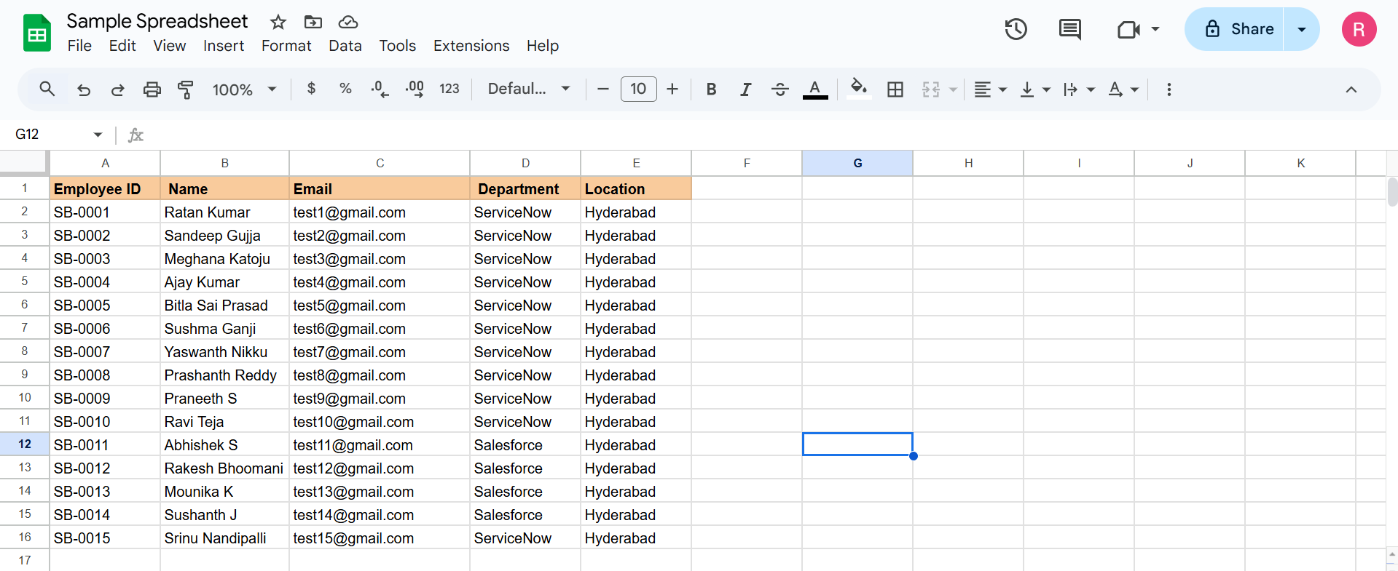
Figure 1: Sample employee data in Google Spreadsheet
5. Folder Structure
• Client: ServiceNow has no React folder structure. The user-facing structure is the set of navigator modules and forms used in the project:
o Tables (System Definition) – Employee Test table and form layout.
o Load Data (System Import Sets) – spreadsheet upload.
o Transform Maps – Sample Spreadsheet Import and its Field Maps.
o Employee Test list view – validation of imported records.
o Reports (Usage and governance) and Dashboards (Self Service) – analytics.
• Server: The server-side configuration is organised as platform records rather than Node.js folders:
o Table u_employee_test (target) and table u_employee_import (staging).
o Import Set records and Transform History (insert, update and ignore counts).
o Transform Map records with Field Maps (including Coalesce).
o Report records (3) and the dashboard record Employee Analytics Dashboards (pa_dashboards).
o ACL pa_dashboards (create operation) – Admin Overrides enabled to open PA_DASHBOARDS.FORM.
6. Running the Application
• Provide commands to start the frontend and backend servers locally.
o Frontend: No npm start is needed. Log in to the ServiceNow instance and open Employee Test from the Application Navigator to view the data, and open Dashboards > Employee Analytics Dashboards to view the reports.
o Backend: No npm start is needed. The platform runs the server, and the import is executed from the UI: All > System Import Sets > Load Data > Submit > Run Transform (next steps) > select Sample Spreadsheet Import > click Transform.
o Re-import test (Phase 7): Load a second Excel file (4 rows: 2 existing IDs with changed Name/Email and 2 new IDs) into the existing Employee Import table and run the transform. Result: 4 rows uploaded, 2 inserted and 2 updated. Loading the same sheet again gives 0 inserted, 0 updated and 4 ignored, so no duplicates are created.
7. API Documentation
• Document all endpoints exposed by the backend.
• This project does not expose any custom REST endpoints, because the import is run through the ServiceNow UI (Load Data and Transform Map). Data is accessed through standard ServiceNow platform features.
• Include request methods, parameters, and example responses.
• For reference, the imported data can also be read through the standard ServiceNow Table API (optional, not used in this project):
Method | Endpoint | Description
GET | /api/now/table/u_employee_test | List all Employee Test records
GET | /api/now/table/u_employee_test?sysparm_query=u_employee_id=SB-0004 | Get one employee by Employee ID
GET | /api/now/table/u_employee_import | List rows loaded into the Import Set table
Example response (illustrative, GET /api/now/table/u_employee_test?sysparm_limit=1):
{ "result": [ {
"u_employee_id": "SB-0004",
"u_employee_name": "Ajay",
"u_email": "<employee email>",
"u_department": "ServiceNow",
"u_location": "Hyderabad"
} ] }
8. Authentication
• Explain how authentication and authorization are handled in the project.
• Authentication is handled by ServiceNow itself (instance login with user name and password, or the organisation’s SSO). No custom JWT or session code was written.
• Include details about tokens, sessions, or any other methods used.
o Roles: The import, table creation, transform map and report work were done with the admin role.
o Sessions: The ServiceNow platform manages the user session after login. No custom tokens are used.
o ACL: To create dashboards through the backend form PA_DASHBOARDS.FORM, the ACL for pa_dashboards (Create operation) was opened and Admin Overrides was set to true.
o Sharing: Dashboard and report access can be restricted by Users, Groups and Roles from the Share option.
9. User Interface
• Provide screenshots or GIFs showcasing different UI features.
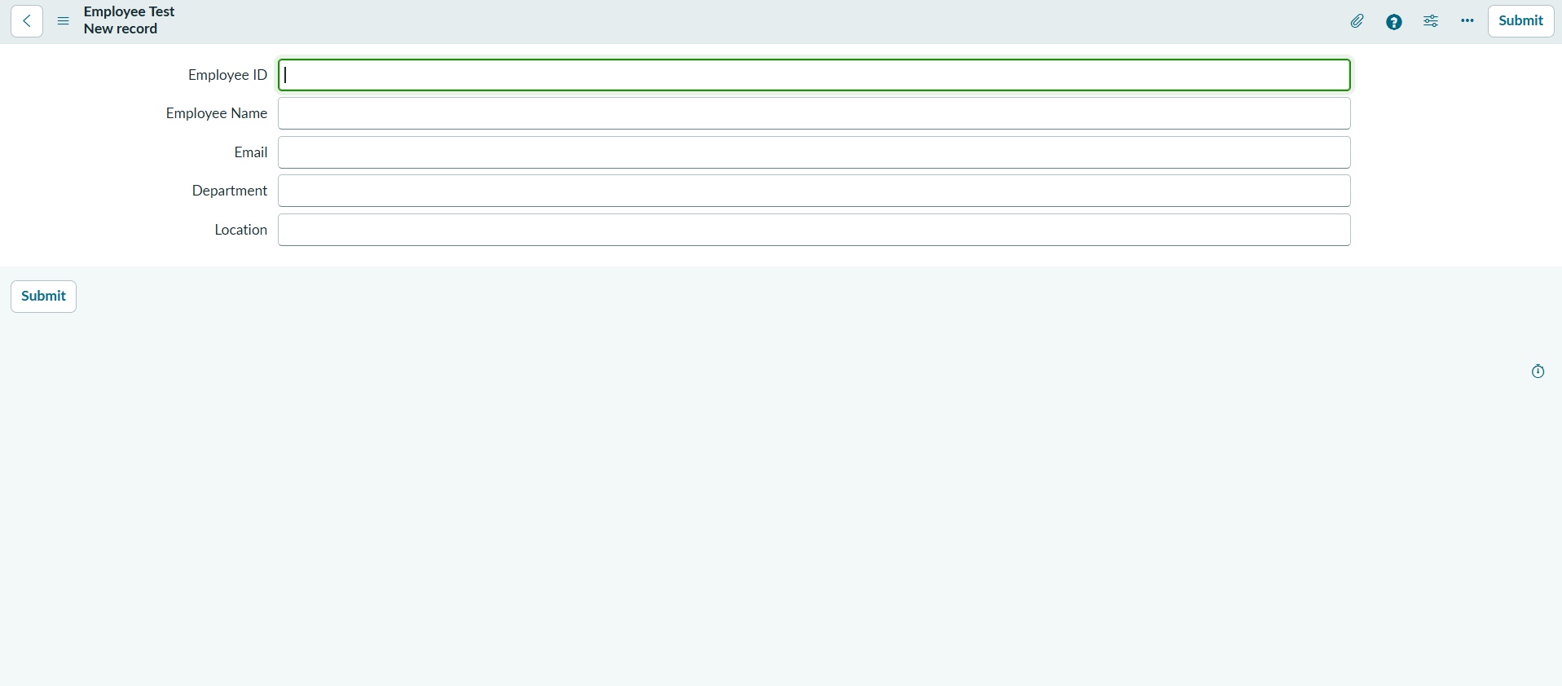
Figure 2: Employee Test form with Employee ID, Name, Email, Department and Location
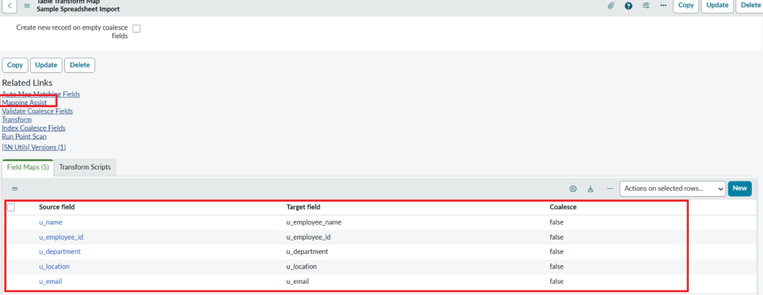
Figure 3: Transform Map field mapping (source to target)
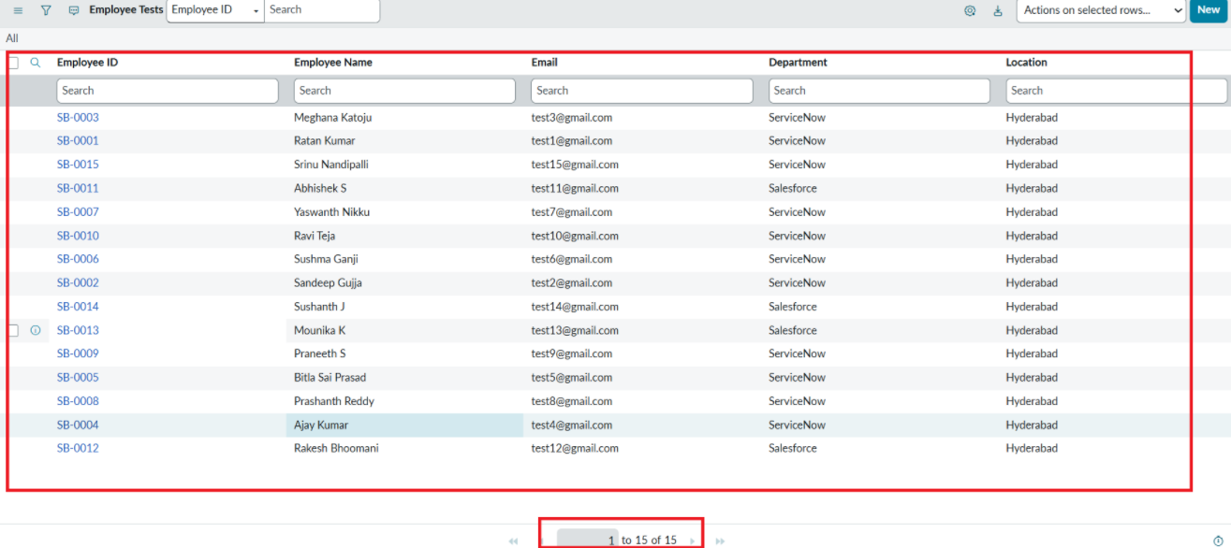
Figure 4: Imported records in the Employee Test table
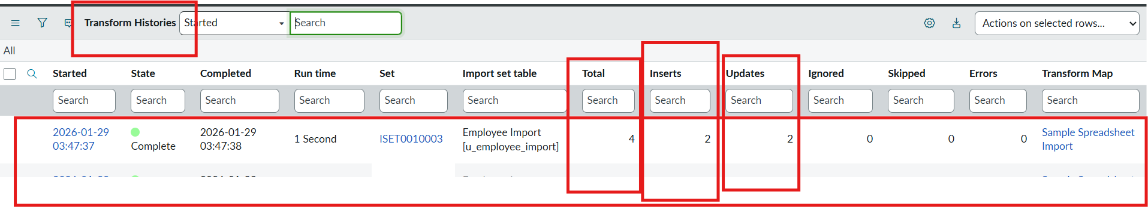
Figure 5: Transform History – 4 rows loaded, 2 inserted, 2 updated
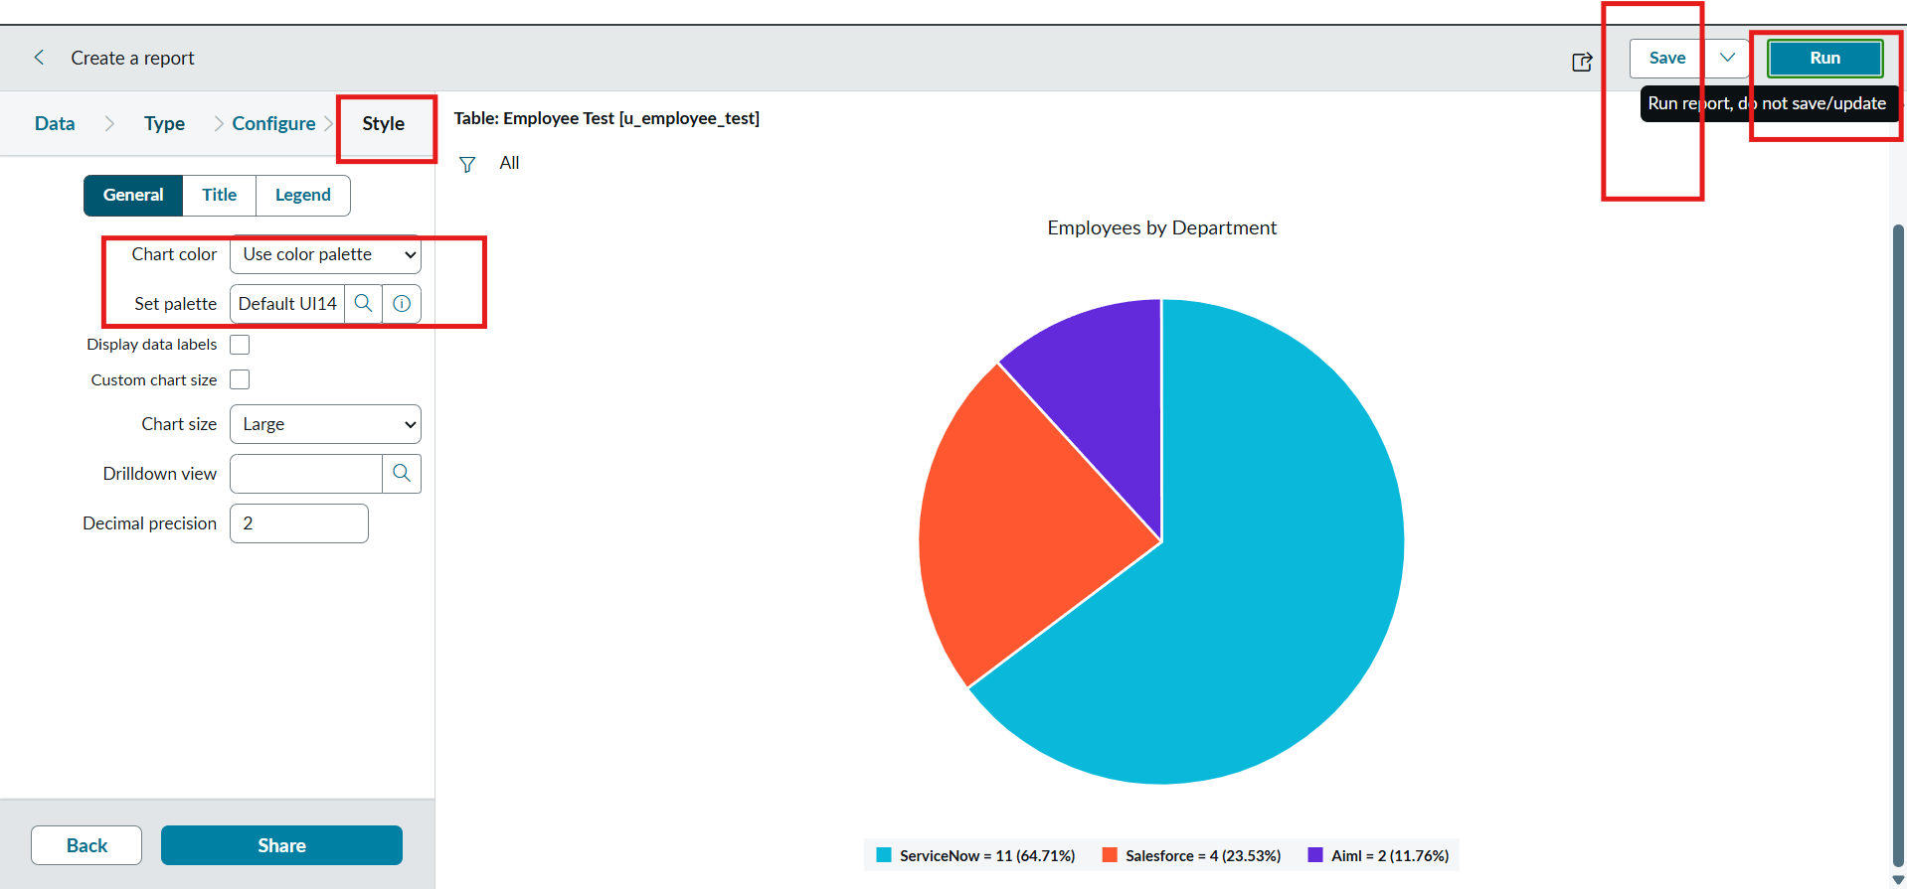
Figure 6: Employees by Department (Pie chart)
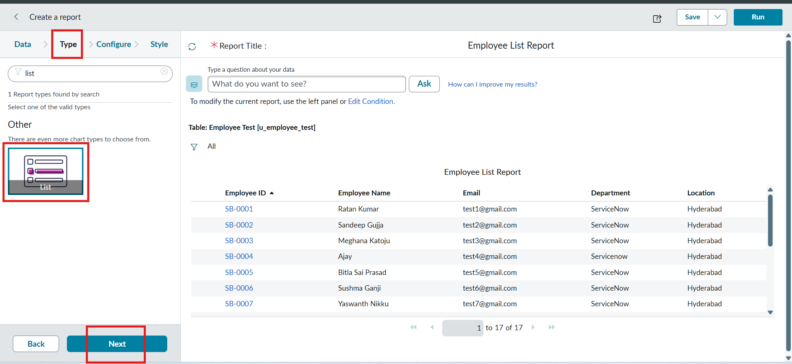
Figure 7: Employee List Report (List)
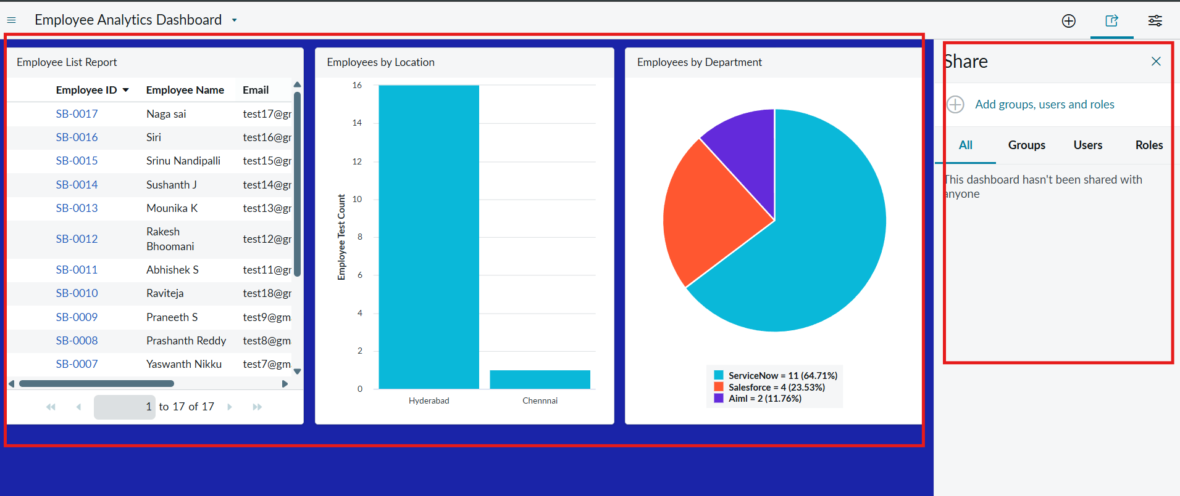
Figure 8: Employee Analytics Dashboards with three reports and Share options
10. Testing
• Describe the testing strategy and tools used.
• Testing was manual and functional, using the ServiceNow UI and its built-in Transform History.
o Import test: After clicking Transform, the success message was checked and all spreadsheet rows were confirmed in the Employee Test table.
o Field mapping test: Source and target fields in the Field Maps related list were verified before transforming.
o Coalesce – update test: Four rows were loaded, two with changed values and two new. Transform History showed 2 inserted and 2 updated, and the changed Name/Email values were confirmed in Employee Test.
o Coalesce – duplicate test: The same sheet was loaded again. Transform History showed 0 inserted, 0 updated and 4 ignored, so no duplicates were created.
o Report and dashboard test: Each report was run and saved, then the dashboard was checked to confirm that all three reports displayed correctly.
o Tools used: ServiceNow Transform History, list views and report preview.
11. Screenshots or Demo
• Provide screenshots or a link to a demo to showcase the application.
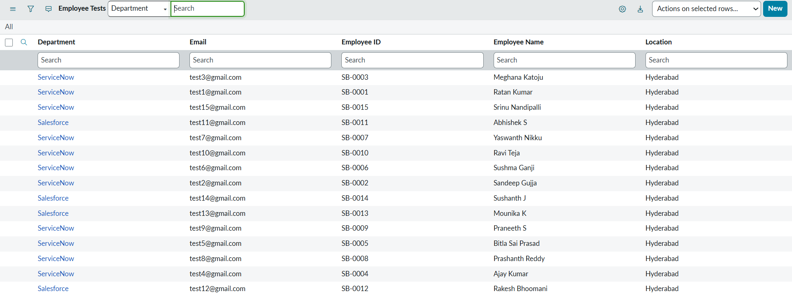
Figure 9: Employee Test table after the first import
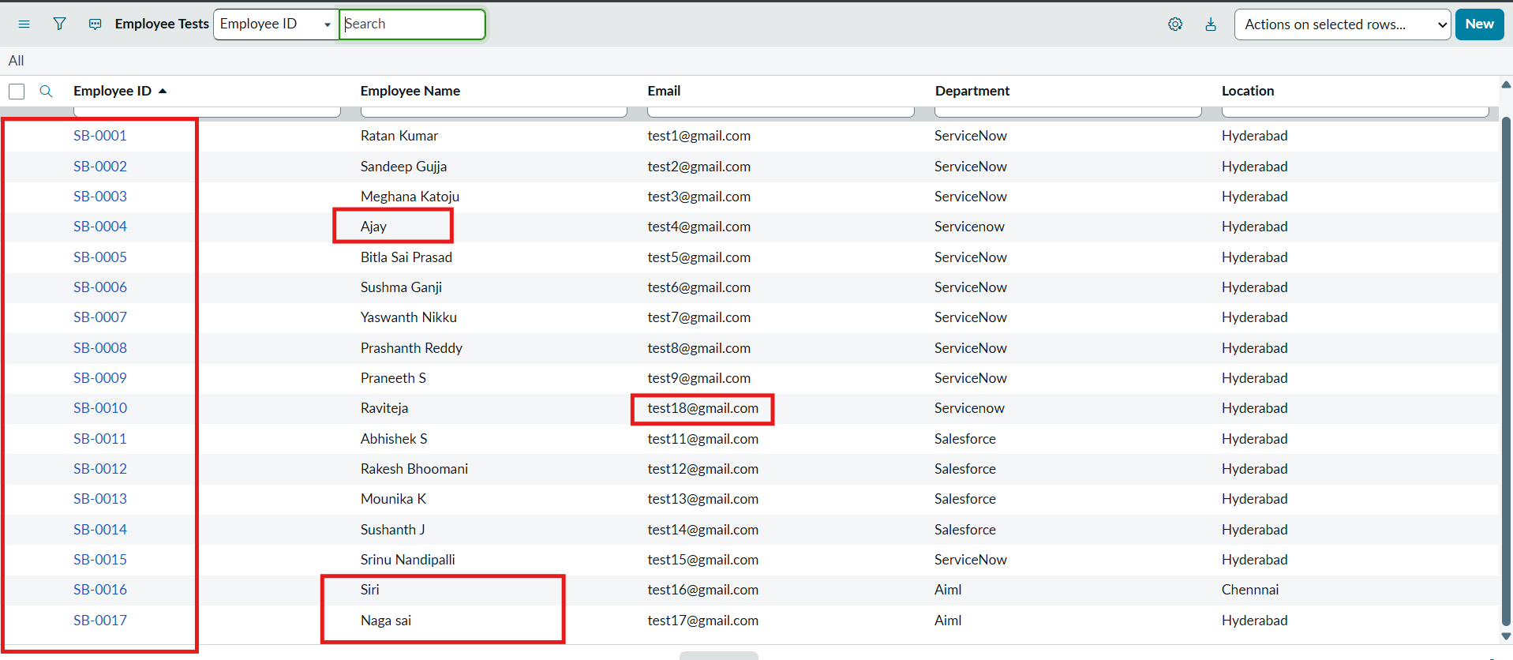
Figure 10: Updated and newly inserted rows after the second import
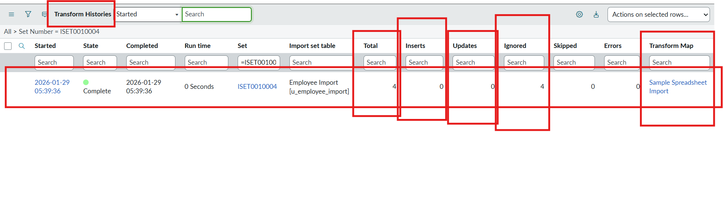
Figure 11: Re-import of the same sheet – 0 inserted, 0 updated, 4 ignored
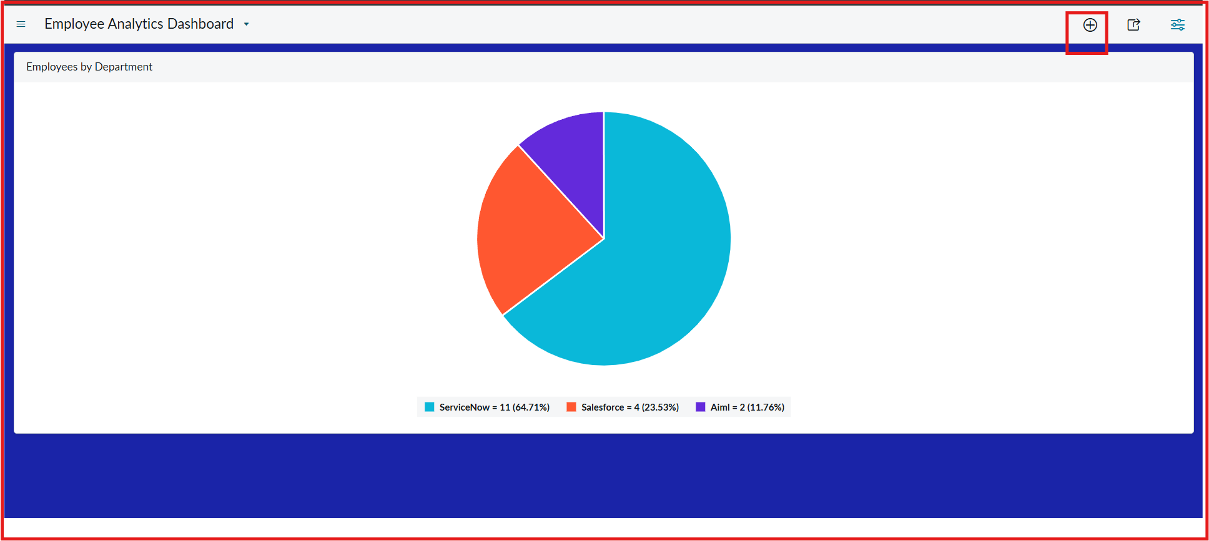
Figure 12: Employees by Department report on the dashboard
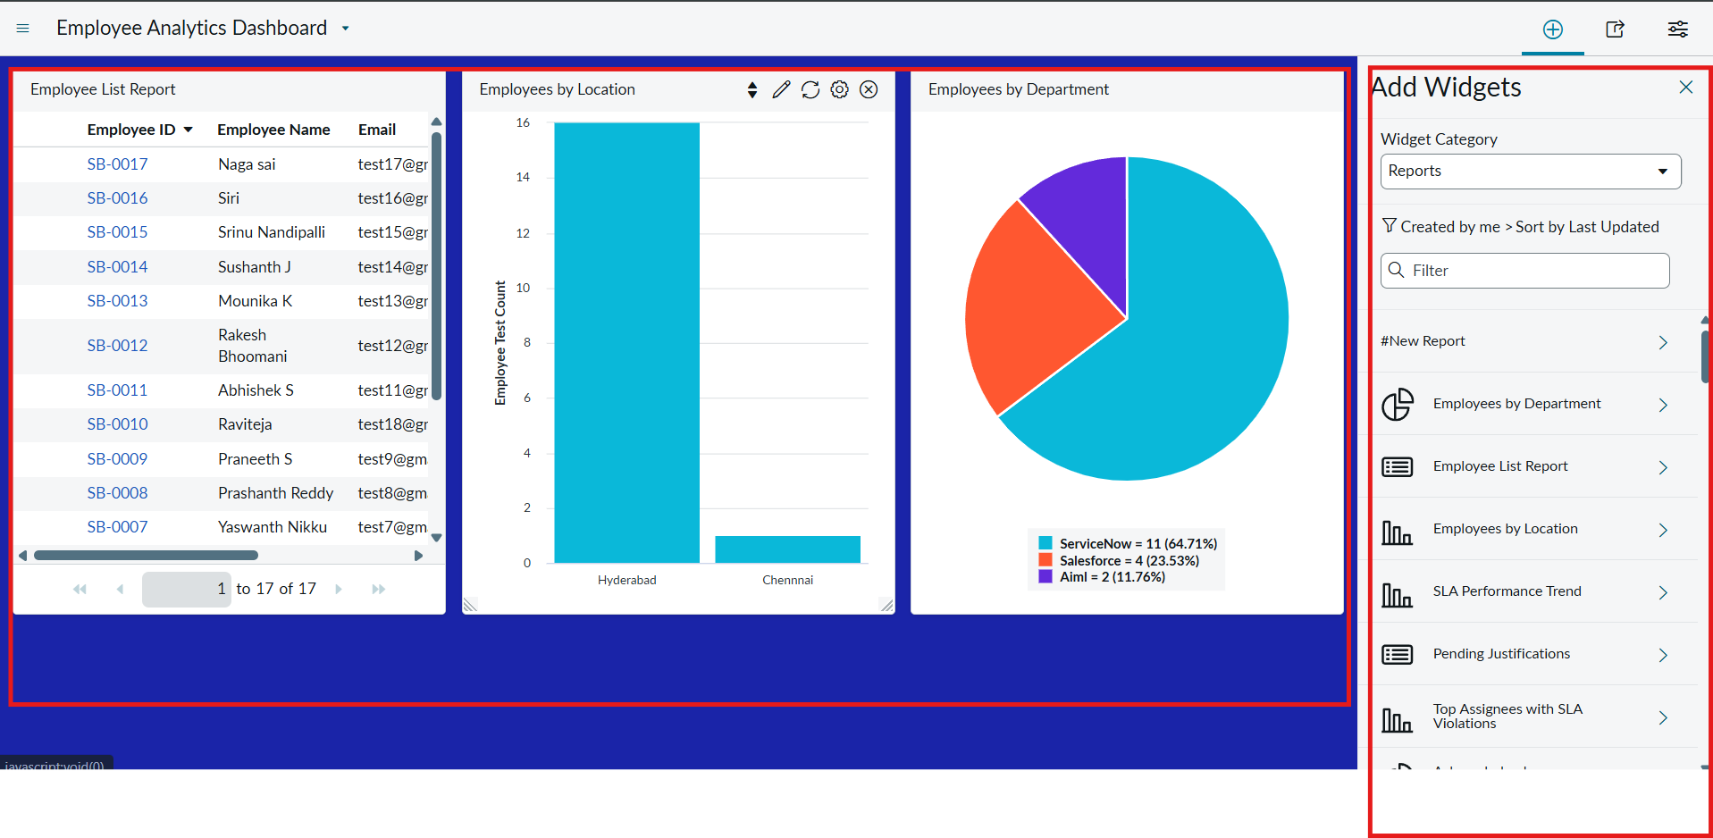
Figure 13: Dashboard with the Employee List, Location and Department reports
12. Known Issues
• Document any known bugs or issues that users or developers should be aware of.
o Coalesce works only on the field(s) marked as coalesce (Employee ID). If the Employee ID in the sheet is typed differently (for example SB-0004 vs SB-OOO4), the row is treated as a new record.
o The dashboard creation form (PA_DASHBOARDS.FORM) opens only after Admin Overrides is enabled on the pa_dashboards Create ACL, which needs admin access.
o All fields are of type String; there is no validation for email format or for unique values apart from Employee ID.
o The import must be repeated manually, and the data is not scheduled or imported automatically.
13. Future Enhancements
• Outline potential future features or improvements that could be made to the project.
o Add field-level validation (email format, mandatory fields, choice lists for Department and Location) using Business Rules or Transform Scripts.
o Schedule the import automatically with a Scheduled Import from a shared location, instead of manual upload.
o Add reports for import monitoring, such as total, newly added and updated records, and import success and error counts.
o Send email notifications to HR or administrators when an import completes or fails.
o Restrict dashboard and table access to HR roles and groups using ACLs and role-based sharing.
o Link the employee records to the User table (sys_user) and extend the import to more employee attributes.

